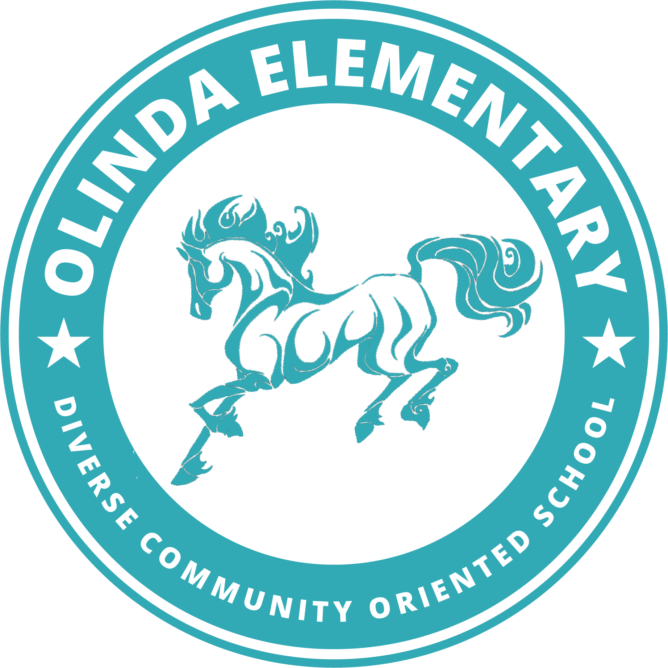August 2021

Welcome to TK! Your Teacher- Ms. Barrios would like you to each bring the following items to school with you the first day in our room 20 classroom. Students need:

**At least two masks in their backpack in case the one they come to school in gets dirty**

[Crayola brand mask pack of five](https://schoolmaskpack.com/products/crayola-kids-reusable-cloth-face-mask-set-cool-colors?gclid=Cj0KCQjw6ZOIBhDdARIsAMf8YyF85AdT0MjoF6sttlMI2F-Gl-tbsdGoVPtllbDi8hjR7y7onChc-ZkaAshPEALw_wcB)

[Target brand mask pack of five](https://www.target.com/p/kids-39-5pk-fabric-face-masks-cat-38-jack-8482-black-pink-green/-/A-81280067?ref=tgt_adv_XS000000&AFID=google_pla_df&fndsrc=tgtao&DFA=71700000014774536&CPNG=PLA_Kids%2BShopping_Brand%7CKids_Ecomm_AA&adgroup=SC_Kids&LID=700000001170770pgs&LNM=PRODUCT_GROUP&network=g&device=c&location=9032085&targetid=aud-1281829994619:pla-896169870156&ds_rl=1246978&ds_rl=1248099&ds_rl=1246984&gclid=Cj0KCQjw6ZOIBhDdARIsAMf8YyE-Tb53K4FDEt-XBPvELVtLPC2aZ0x42E48Dg9_55Yuum01lIYcfwEaAp73EALw_wcB&gclsrc=aw.ds)

Masks should be washed daily- do not send your student to school in a dirty or previously worn, unwashed mask. Masks may have many sorts of decorations, or none at all- we ask that they not have logos of alcohol, profanity, or other items outlined in our student handbook as being inappropriate for school

[Expo or other brand Dry- erase markers](https://www.target.com/p/expo-6pk-dry-erase-marker-starter-set-with-eraser-cleaner-chisel-tip-multicolor/-/A-14790217?ref=tgt_adv_XS000000&AFID=google_pla_df&fndsrc=tmnv&DFA=71700000085191339&CPNG=PLA_DVM%2Ba064R000011tbfcQAA-Newell_2021+BTS+Solo+Campaign_Flight&adgroup=PLA_Newell&LID=700000001393753pgs&network=g&device=c&location=9032085&gclid=Cj0KCQjw6ZOIBhDdARIsAMf8YyEPP0yOqHjg0syG1RbKXfhGm_Z4u0rYx7tE_UPLvB-LVk9VKIPhIAcaAknYEALw_wcB&gclsrc=aw.ds)

[One container of Clorox wipes to clean their desk with](https://www.target.com/p/clorox-disinfecting-wipes-bleach-free-cleaning-wipes/-/A-82804633?preselect=12992463#lnk=sametab)

[2 bottles of Elmer’s School Glue with the Orange cap](https://www.target.com/p/elmer-39-s-washable-school-glue-7-625oz/-/A-17089133#lnk=sametab)

[A box of tissues](https://www.target.com/p/facial-tissues-up-up/-/A-79834432?preselect=53524230#lnk=sametab)

[Post-it or other type sticky nortes in various sizes](https://www.target.com/p/post-it-15ct-super-sticky-notes-pack-miami-collection/-/A-51586280#lnk=sametab)

[Masking tape- 1 inch wide](https://www.target.com/p/scotch-94-34-x-60yd-masking-tape/-/A-13717042#lnk=sametab)

[A large pack of sidewalk chalk](https://www.target.com/p/50ct-sidewalk-chalk-set-mondo-llama/-/A-82531868?preselect=81387914#lnk=sametab)

[A 12” x 12” plastic document or scrapbook case](https://www.michaels.com/12in-x-12in-clear-scrapbook-case-by-simply-tidy/10575615.html)

These items and the links are examples of what you will need- if you find the same item elsewhere- please don’t feel as though you must only buy at target! If you have any questions, [check the website](https://www.wccusd.net/olinda) where you will find the FAQ, links to the student handbook, the daily bell schedule, and other items!

